**Endocrine System**

* Hormones are defined as **organic substances**, produced in small amounts by specific tissues (endocrine glands), secreted into the blood stream to control the metabolic and biological activities in the target cells.
* Hormones may be regarded as the **chemical messengers** involved in the transmission of information form one tissue to another and from cell to cell.
* Endocrine tissue are highly vascular.
* The endocrine system consists of a number of distinct glands and some tissues in other organs.
* Although the hypothalamus is classified as a part of the brain and not as an endocrine gland it controls the pituitary gland and has an indirect effect on many others.
* The endocrine glands are:
  + 1 pituitary gland
  + 1 thyroid gland
  + 4 parathyroid glands
  + 2 adrenal (suprarenal) glands
  + the pancreatic islets (islets of Langerhans)
  + 1 pineal gland or body
  + 1 thymus gland
  + 2 ovaries in the female
  + 2 testes in the male.

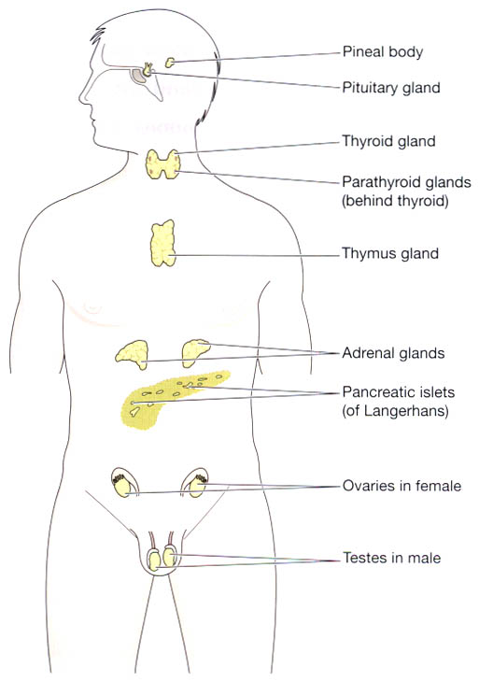

**Fig:** Positions of the endocrine glands.

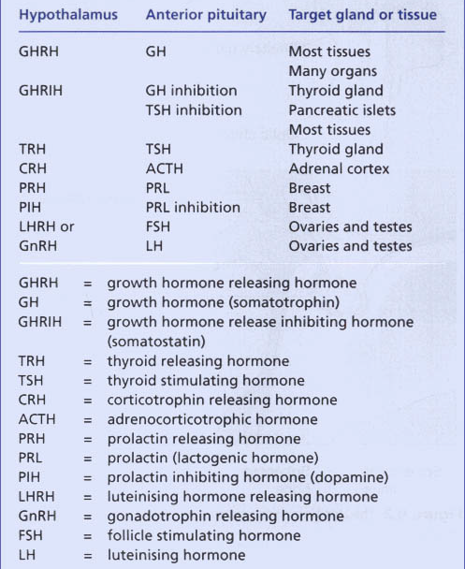

*Table: Hormones of the hypothalamus, anterior pituitary and their target tissues*

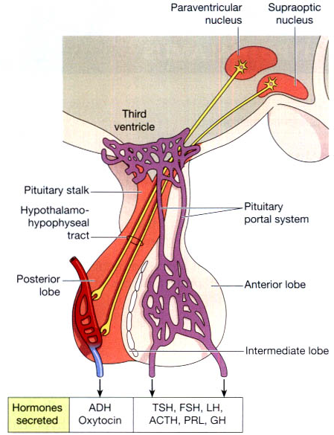

Fig: The pituitary gland. The lobes of the pituitary gland and their relationship with the hypothalamus.

**Growth Hormone**: Introduction

* A product of the anterior part of the pituitary gland that promotes normal growth and development in the body by changing the chemical activity in the cells.
* The hormone activates protein production in the muscle cells as well as the release of energy from the metabolism of fats.
* Its release is controlled by the contrasting actions of growth-hormone releasing factor and somatostatin.
* If the body produces too much growth hormone before puberty **Gigantism** results; in adulthood the result is **Acromegaly**.
* Lack of growth hormone in children retards growth.

**Gigantism.**

* Occasionally, growth hormone–producing cells of the anterior pituitary gland become excessively active, and sometimes even tumors occur in the gland.
* As a result
  + large quantities of growth hormone are produced.
  + All body tissues grow rapidly, including the bones.
* If the condition occurs before adolescence, before the epiphyses of the long bones have become fused with the shafts, height increases so that the person becomes a giant up to 8 feet tall.
* The giant ordinarily has hyperglycemia, and the beta cells of the islets of Langerhans in the pancreas are prone to degenerate because they become overactive owing to the hyperglycemia.
* Consequently, in about 10 per cent of giants, full-blown diabetes mellitus eventually develops.
* The main clinical feature in gigantism is the excessive and proportionate growth of the child.
* There is enlargement as well as thickening of the bones resulting in considerable increase in height and enlarged thoracic cage.

**Acromegaly**

* If a tumor occurs after adolescence that is, after the epiphyses of the long bones have fused with the shafts the person cannot grow taller, but the bones can become thicker and the soft tissues can continue to grow.
* Acromegaly results when there is overproduction of GH in adults following cessation of bone growth and is more common than gigantism.
* The term ‘acromegaly’ means increased growth of extremities (*acro=extremity).*
* There is enlargement of hands and feet, coarseness of facial features with increase in soft tissues, prominent supraorbital ridges and a more prominent lower jaw which when clenched results in protrusion of the lower teeth in front of upper teeth *(prognathism).*
* Other features include enlargement of the tongue and lips, thickening of the skin and kyphosis.
* Enlargement is especially marked in the
  + the lower jaw protrudes forward, sometimes as much as half an inch
  + the forehead slants forward because of excess development of the supraorbital ridges
  + the nose increases to as much as twice normal size
  + the feet require size 14 or larger shoes
  + the fingers become extremely thickened so that the hands are almost twice normal size.
  + In addition to these effects
    - changes in the vertebrae ordinarily cause a hunched back, (kyphosis)
    - Finally, many soft tissue organs, such as the tongue, the liver, and especially the kidneys, become greatly enlarged.

**Dwarfism:**

* Severe deficiency of GH in children before growth is completed results in retarded growth and pituitary dwarfism.
* Most commonly, isolated GH deficiency is the result of an inherited autosomal recessive disorder.
* Less often it may be due to a pituitary adenoma, infarction and trauma to the pituitary.
* The clinical features of inherited cases of pituitary dwarfism appear after one year of age.
* These include proportionate retardation in growth of bones, normal mental state for age, poorly-developed genitalia, delayed puberty and episodes of hypoglycaemia.

Thyroid Hormone

* Often referred to as the body’s major metabolic hormone, thyroid hormone (TH) is actually two iodine-containing amine hormones
  1. thyroxine or T4,
  2. triiodothyronine or T3.
* T4 is the major hormone secreted by the thyroid follicles; most T3 is formed at the target tissues by conversion of T4 to T3.
* The principal difference is that T4 has four bound iodine atoms, and T3 has three (thus,T4 and T3).
* Very much like one another, the hormones are constructed from two linked tyrosine amino acids.

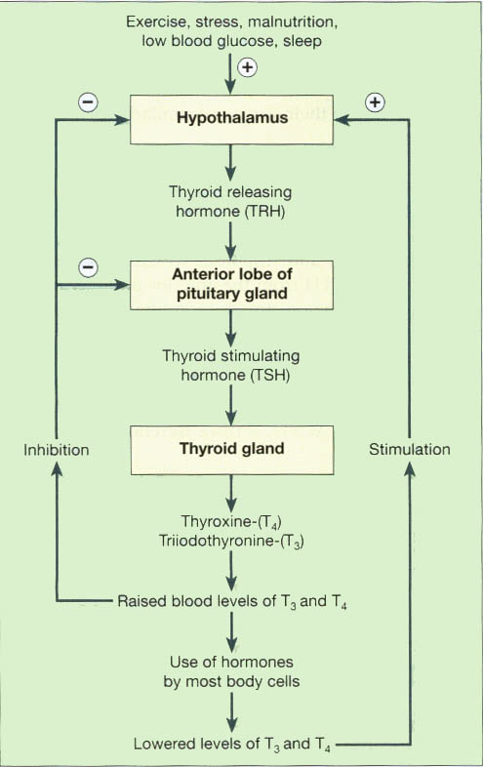

**Fig:** Regulation of the secretion of thyroxine (T4) and triiodothyronine (T3).

1. **Hypothyroidism:**
   * Myxedma
   * Decreased basal metabolic rate
   * Sensitivity to cold
   * Sleepiness
   * Slow heart rate

**Clinical features:**

* + T3, T4 = decreased
  + TSH = increased

**2. Hyperthyroidism:**

* Grave’s disease
* Excessive sweating
* Sensitivity to heat
* Inability to sleep
* Rapid heart rate

**Clinical features:**

* + T3, T4 = increased
  + TSH = decreased

**Hyperthyroidism**

**Causes of Hyperthyroidism**

**Toxic Goiter**

* The thyroid gland is increased to two to three times normal size, with tremendous hyperplasia and infolding of the follicular cell lining into the follicles, so that the number of cells is increased greatly.
* Also, each cell increases its rate of secretion several fold; at rates 5 to 15 times normal.

**Thyrotoxicosis**

* The changes in the thyroid gland in most instances are similar to those caused by **excessive TSH**.
* Other substances that have actions similar to those of TSH are found in the blood of almost all these patients. i.e. immunoglobulin antibodies c/o **thyroid-stimulating immunoglobulin (TSI).**
* Hyperthyroidism occasionally results from a localized **adenoma** (a tumor) that develops in the thyroid tissue and secretes large quantities of thyroid hormone.

**Exophthalmos (Graves Disease)**

* Most people with hyperthyroidism develop some degree of protrusion of the eyeballs, as condition is called exophthalmos.
* A major degree of exophthalmos occurs in about one third of hyperthyroid patients, and the condition sometimes becomes so severe that the eyeball protrusion stretches the optic nerve enough to damage vision.
* the eyes are damaged because the eyelids do not close completely when the person blinks or is asleep.
* the epithelial surfaces of the eyes become dry and irritated and often infected, resulting in ulceration of the cornea.
* The cause of the protruding eyes is edematous swelling of the retro-orbital tissues and degenerative changes in the extra-ocular muscles
* The exophthalmos of Graves’ disease is due to autoimmunity.
* Antibodies to surface antigens on the eye muscles are produced and this causes an inflammatory reaction in the muscle and retro-orbital tissues.

**The symptoms of hyperthyroidism**

1. a high state of excitability
2. intolerance to heat
3. increased sweating
4. mild to extreme weight loss (sometimes as much as 100 pounds)
5. varying degrees of diarrhea
6. muscle weakness
7. nervousness or other psychic disorders
8. extreme fatigue but inability to sleep
9. tremor of the hands

**HYPOTHYROIDISM**

Hypothyroidism is a hypometabolic clinical state resulting from **inadequate** production of thyroid hormones for prolonged periods, or rarely, from **resistance** of the peripheral tissues to the effects of thyroid hormones.

The clinical manifestations of hypothyroidism, depending upon the age at onset of disorder, are divided into 2 forms:

* 1. *Cretinism or congenital hypothyroidism* is the development of severe hypothyroidism during infancy and childhood.
  2. *Myxoedema* is the adulthood hypothyroidism.

**Cretinism**

* Cretinism is caused by extreme hypothyroidism during fetal life, infancy, or childhood.
* This condition is characterized especially by failure of body growth and by mental retardation.
* It results from
  + congenital lack of a thyroid gland (congenital cretinism), from failure of the thyroid gland to produce thyroid hormone because of a **genetic defect** of the gland
  + from iodine lack in the diet (endemic cretinism).
  + A neonate without a thyroid gland may have normal appearance and function because it was supplied with some (but usually not enough) thyroid hormone by the mother while in utero, but a few weeks after birth, the neonate’s movements become sluggish and both physical and mental growth begin to be greatly retarded.

**CLINICAL FEATURES.**

* + slow to thrive,
  + poor feeding,
  + constipation,
  + dry scaly skin,
  + hoarse cry and
  + bradycardia.
  + impaired skeletal growth and consequent dwarfism,
  + round face,
  + narrow forehead,
  + widely-set eyes,
  + flat and broad nose,
  + big protuberant tongue and protuberant abdomen.
* Characteristic laboratory findings include a rise in TSH level and fall in T3 and T4 levels.

**Myxedema**

* Myxedema develops in the patient with almost total lack of thyroid hormone function.
  + demonstrating bagginess under the eyes
  + swelling of the face.
* In this condition, greatly increased quantities of **hyaluronic acid** and **chondroitin sulfate** bound with protein form excessive tissue gel in the interstitial spaces, and this causes the total quantity of **interstitial ﬂuid to increase**.
* Because of the gel nature of the excess ﬂuid, it is mainly immobile, and the edema is the non-pitting type.

**CLINICAL FEATURES.**

* Cold intolerance,
* Mental and physical lethargy,
* Constipation,
* Slowing of speech and intellectual function,
* Puffiness of face,
* Loss of hair and altered texture of the skin.
* The laboratory diagnosis in myxoedema is made by low serum T3 and T4 levels and markedly elevated TSH levels as in the case of cretinism but cases with suprathyroid lesions (hypothalamic-pituitary disease) have low TSH levels.

**Hashimoto’s Thyroiditis:**

* A condition in which the whole of the thyroid gland is diffusely **enlarged** and firm.
* It is one of the diseases produced by **autoimmunity**.
* The enlargement is due to diffuse **infiltration of lymphocytes and increase of fibrous tissue.**
* This form of goiter appears in middle-aged women, does not give rise to symptoms of thyrotoxicosis and tends to produce myxoedema.

Hashimoto’s thyroiditis, also called diffuse lymphocytic thyroiditis, struma lymphomatosa or goitrous autoimmune thyroiditis, is characterised by 3 principal features:

* + 1. Diffuse goitrous enlargement of the thyroid.
    2. Lymphocytic infiltration of the thyroid gland.
    3. Occurrence of thyroid autoantibodies.

**ETIOPATHOGENESIS.**

1. **Other autoimmune disease association:** Graves’ disease, SLE, rheumatoid arthritis, pernicious anaemia and Type 1 diabetes mellitus.
2. **Immune destruction of thyroid cells:** Infiltration of CD8+ T cytotoxic cells in the thyroid parenchyma as well as activate B cells to form autoantibodies,
3. **Detection of autoantibodies:**

i) Thyroid microsomal autoantibodies (against the microsomes of the follicular cells).

ii) Thyroglobulin autoantibodies.

iii) TSH receptor autoantibodies.

1. **Inhibitory TSH-receptor antibodies:** TSH-receptorantibody seen on the surface of thyroid cells in Hashimoto’s thyroiditis is inhibitory to TSH, producing hypothyroidism.
2. **Genetic basis**

**Morphologic Features**

Pathologically, two forms: *classic form,* the usual and more common, and *fibrosing variant*

**Grossly**, the ***classic form*** is characterised by diffuse, symmetric, firm and rubbery enlargement of the thyroid which may weigh 100-300 gm. Sectioned surface of the thyroid is fleshly. The *fibrosing variant* has a firm, enlarged thyroid with compression of the surrounding tissues.

***Histologically,*** the classic form shows the following features**:**

1. **Infiltration** of the gland by lymphocytes, plasma cells, immunoblasts and macrophages
2. **Decreased** number of thyroid follicles
3. The follicular epithelial cells are transformed into their **degenerated state** termed **Hurthle cells** (also called Askanazy cells, or oxyphil cells, or oncocytes).
4. There is slight fibrous **thickening of the septa** separating the thyroid lobules.

The less common *fibrosing variant* of Hashimoto’s thyroiditis shows considerable **fibrous replacement of thyroid parenchyma** and a less prominent lymphoid infiltrate.

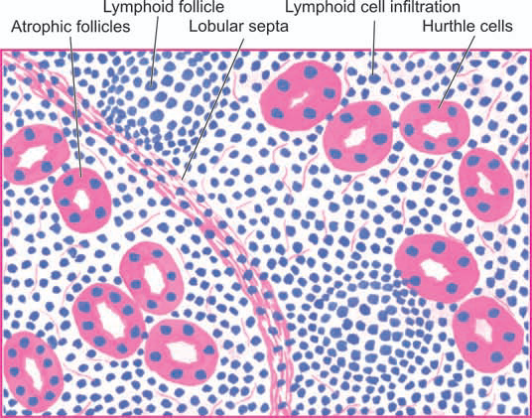

**Fig: Hashimoto’s thyroiditis.** Histologic features include: lymphoid cell infiltration with formation of lymphoid follicles having germinal centres; small, atrophic and colloid-deficient follicles; presence of Hurthle cells which have granular cytoplasm and large irregular nuclei; and slight fibrous thickening of lobular septa.

**Cushing’s Syndrome (Chronic Hypercortisolism)**

*Cushing’s* syndrome caused by excess of glucocorticoids (i.e. cortisol); also called *chronic hypercortisolism.*

**ETIOPATHOGENESIS**

1. **Pituitary Cushing’s syndrome**
   * Excessive secretion of ACTH due to a lesion in the pituitary gland, most commonly a corticotroph adenoma or multiple corticotroph microadenomas.
   * Described by Harvey Cushing, an American neurosurgeon
   * Characterised by bilateral adrenal cortical hyperplasia and elevated ACTH levels.
2. **Adrenal Cushing’s syndrome**
   * Caused by disease in one or both the adrenal glands.
   * Include adrenal cortical adenoma, carcinoma, and less often, cortical hyperplasia.
3. **Ectopic Cushing’s syndrome**
   * The tumour is an oat cell carcinoma of the lung but other lung cancers, malignant thymoma and pancreatic tumours have also been implicated.
4. **Iatrogenic Cushing’s syndrome**
   * Prolonged therapeutic administration of high doses of glucocorticoids or ACTH may result in Cushing’s syndrome e.g. in organ transplant recipients and in autoimmune diseases.

**CLINICAL FEATURES**

Between the age of 20-40 years with three times higher frequency in women than in men.

1. Central or truncal ***obesity***contrasted with relatively thin arms and legs, buffalo hump due to prominence of fat over the shoulders, and rounded edematous moon-face.
2. Increased ***protein breakdown*** resulting in wasting and thinning of the skeletal muscles, atrophy of the skin and subcutaneous tissue with formation of purple striae on the abdominal wall, osteoporosis and easy bruisability of the thin skin to minor trauma.
3. ***Systemic hypertension*** is present in 80% of cases because of associated retention of sodium and water.
4. ***Impaired glucose tolerance*** and***diabetes mellitus*** are found in about 20% cases.
5. Amenorrhoea, hirsutism and infertility in many women.
6. Insomnia, depression, confusion and psychosis.

**Addision’ Disease:**

* Adrenocortical Insufficiency (Hypoadrenalism)
* Adrenocortical insufficiency may result from deficient synthesis of cortical steroids from the adrenal cortex or may be secondary to ACTH deficiency.
* Progressive chronic destruction of more than 90% of adrenal cortex on both sides

**Etiopathogenesis:**

* Any condition which causes marked chronic adrenal destruction may produce Addison’s disease.
* These include: tuberculosis, autoimmune or idiopathic adrenalitis, histoplasmosis, amyloidosis, metastatic cancer, sarcoidosis and haemochromatosis.

**CLINICAL FEATURES**

Clinical manifestations develop slowly and insidiously. The usual features are as under:

1. Asthenia i.e. progressive weakness, weight loss and lethargy as the cardinal symptoms.
2. Hyperpigmentation, initially most marked on exposed areas, but later involves unexposed parts and mucous membranes as well.
3. Arterial hypotension.
4. Loss of appetite, nausea, vomiting and upper abdominal pain.
5. Lack of androgen causing loss of hair in women.
6. Episodes of hypoglycaemia.
7. Biochemical changes include reduced GFR, acidosis, hyperkalaemia and low levels of serum sodium, chloride and bicarbonate.

**DIABETES MELLITUS**

**Definition and Epidemiology**

* WHO defined as a hetrogeneous metabolic disorder characterised by common feature of chronic hyperglycaemia with disturbance of carbohydrate, fat and protein metabolism.
* The incidence is rising in the developed countries of the world at the rate of about 10% per year, especially of type 2 DM, due to rising incidence of obesity and reduced activity levels.
* DM is expected to continue as a major health problem owing to its serious complications, especially end-stage renal disease, IHD, gangrene of the lower extremities, and blindness in the adults.
* Diabetes mellitus is the third leading cause of death (after heart disease and cancer) in many developed countries.
* lt affects about 2 to 3% of the general population.
* The complications of diabetes affect the eye, kidney and nervous system.
* Diabetes is a major cause of blindness, renal failure, amputation, heart attacks and stroke.
* As the disease progresses, patients are at risk for the development o specific complications, including **retinopathy** leading to blindness, **nephropathy** leading to renal failure, **neuropathy** leading to nerve damage, and atherosclerosis.
* Since affected people excrete large quantities of urine with a sweet taste, the condition is named diabetes mellitus.

**Classification:**

Diabetes mellitus is broadly divided into 2 groups, namely

* 1. Type I DM or insulin-dependent diabetes mellitus (IDDM) or juvenile-onset diabetes
  2. Type II DM or non-insulin dependent diabetes mellitys( NIDDM) or adult-onset diabetes

**Type I DM:**

* IDDM, also known as type I diabetes or (less frequently) juvenile onset diabetes, mainly occurs in childhood (particularly between l2 -15 yrs age).
* IDDM accounts for about 10-20% of the known diabetics.
* This disease is characterized by almost total deficiency of insulin due to destruction of B-cells of pancreas.
* The b-cell destruction may be caused by drugs, viruses or autoimmunity. Due to certain genetic variation, the B-cells are recognized as non-self and they are destroyed by immune mediated injury.
* Usually, the symptoms of diabetes appear when 80-90% of the b-cells have been destroyed.
* The pancreas ultimately fails to secrete insulin in response to glucose ingestion.
* The patients of IDDM require insulin therapy.

**Type II DM:**

* Accounting for 80-90%of the diabetic population.
* NIDDM occurs in adults (usually above 35 years) and is less severe than IDDM.
* Causative factors include genetic and environmental.
* More commonly occurs in obese individuals with overeating coupled with under activity leading to obesity
* Obesity acts as a diabetogenic factor in genetically predispose individuals by increasing the resistance to the action of insulin.
* This is due to a decrease in insulin receptors on the insulin responsive (target) cells.
* It is suggested that over-eating causes increased insulin production but decreased synthesis of insulin receptors.

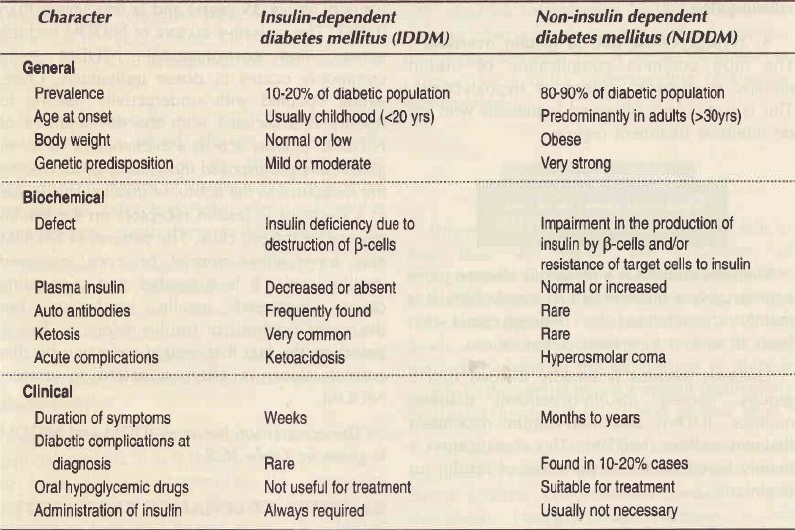

**Biochemical and Clinical Symptoms of DM:**

1. Hyperglycemia
2. Glycosuria
3. Polyuria (increased urination)
4. Polydypsia (increased thirst)
5. Polyphagia (increased hunger)
6. Ketoacidosis
7. Weight loss
8. Delayed wound healing
9. Coma and death, if untreated

**Criteria for diagnosis of DM:**

1. Clinical **symptoms of diabetes.**
2. Elevated **fasting** venous plasma glucose ≥140 mg/dl on more than one occasion. (American Diabetes Association; **>126 mg/dl**).
3. Elevated **post-prandial** venous plasma glucose **≥200 mg/dl**.
4. Random glucose **≥200 mg/dl** in patients with symptoms of diabetes.
5. Elevated **post glucose (PG)** venous plasma glucose **≥200 mg/dl**. Glucose (1.75 gm/kg) is given to the patients orally and time is noted, after 2 hours of ingestion of glucose, PG blood sample is collected.

**Hypoglycemia**:

* When the blood glucose concentration falls to **less than 45 mg/dl**, the symptoms of hypoglycemia appear.
* The manifestations include headache, anxiety, confusion, sweating, slurred speech, seizures and coma, and, if not corrected, death.
* All these symptoms are directly and indirectly related to the deprivation of glucose supply to the central nervous system (particularly the brain) due to a fall in blood glucose level.

**Diabetes insipidus**

* This disorder is characterized by the excretion of large volumes of dilute urine (polyuria).
* lt may be due to insufficient levels of ADH or a defect in the receptors of target cells.

**Antidiuretic hormone (ADH)**

* The release of ADH (also called vasopressin) is mostly controlled by osmoreceptors (of hypothalamus) and baroreceptors (of heart). Any increase in the osmolarity of plasma stimulates ADH secretion.

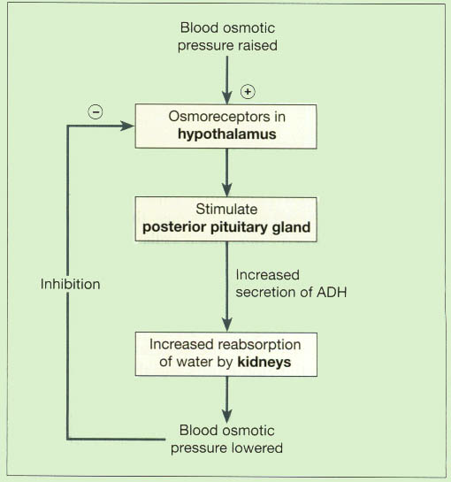

**Biochemical functions:**

* ADH is primarily concerned with the regulation of water balance in the body.
* It stimulates kidneys to retain water and, thus, increases the blood pressure.
* In the absence of ADH, the urine output would be around 20 l/day.
* ADH acts on the distal convoluted tubules of kidneys and causes water reabsorption with a result that the urine output is around 0.5-1.5 l/day.
* Therefore, Diabetes insipidus is a disorder characterized by the deficiency of ADH which results in an increased loss of water from the body.

**Causes of ADH deficiency:**

* Inflammatory and neoplastic lesions of the hypothalamohypophyseal axis, destruction of neurohypophysis due to surgery, radiation, head injury, and sometimes idiopathic.
* The main **features** of diabetes insipidus are excretion of a very large volume of dilute urine of low specific gravity (below 1.010), polyuria and polydipsia.

**Thyroid Tumours**

* Most primary tumours of the thyroid are of follicular epithelial origin; a few arise from parafollicular C-cells.
* The most common benign thyroid neoplasm is a follicular adenoma.
* Malignant tumours of the thyroid are less common but thyroid carcinoma is the most common type.

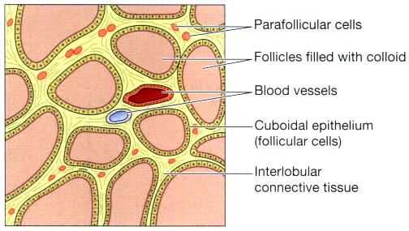

**Fig:** The microscopic structure of the thyroid gland.

**Follicular Adenoma**

* Most common benign thyroid tumour, occurs frequently in adult women.
* Clinically, it appears as a solitary nodule
* Though most adenomas cause no clinical problem and behave as a ‘cold nodule’, rarely they may produce mild hyperthyroidism and appear as ‘hot nodule’.
* Adenoma, however, rarely ever becomes malignant.

**Morphologic Features**

* Small (up to 3 cm in diameter) and spherical.
* On cut section, the adenoma is **grey-white to red-brown**, **less** **colloidal** than the surrounding thyroid parenchyma and may have degenerative changes such as **fibrous scarring**, focal **calcification**, **haemorrhages** and **cyst formation**.
* Grossly, the follicular adenoma is characterised by *four* features**:**
  1. Solitary nodule;
  2. Complete encapsulation;
  3. Clearly different architecture inside and outside the capsule; and
  4. Compression of the thyroid parenchyma outside the capsule

***Histologically,*** the tumour shows complete **fibrous encapsulation**. The tumour cells are benign follicular epithelial cells forming **follicles** of various sizes or may show **trabecular**, **solid** and **cord** patterns with little follicle formation.

Accordingly, the following **6 types** of growth patterns are distinguished;

1. ***Microfollicular*** *(foetal) adenoma* consists of small follicles containing little or no colloid and separated by abundant loose stroma.
2. ***Normofollicular*** *(simple) adenoma* has closely packed follicles like that of normal thyroid gland.
3. ***Macrofollicular*** *(colloid) adenoma* contains large follicles of varying size and distended with colloid.
4. ***Trabecular*** *(embryonal) adenoma* consists of closely packed solid or trabecular pattern of epithelial cells
5. ***Hurthle cell*** *(oxyphilic) adenoma* composed of solid trabeculae of large cells having abundant granular cytoplasm and vesicular nuclei and cells do not form follicles and contain little stroma.
6. ***Atypical*** *adenoma has* more pronounced cellular proliferation with pleomorphism, increased mitoses and nuclear atypia.

**Thyroid Cancer**

* Approximately 95% of all primary thyroid cancers are carcinomas.
* Carcinoma of the thyroid gland has 4 major morphologic types with distinctly different clinical behaviour and variable prevalence.
* These are: **papillary**, **follicular**, **medullary** and undifferentiated (**anaplastic**) carcinoma.

**Table: Contrasting Features of Main Histologic Types of Thyroid Carcinoma.**

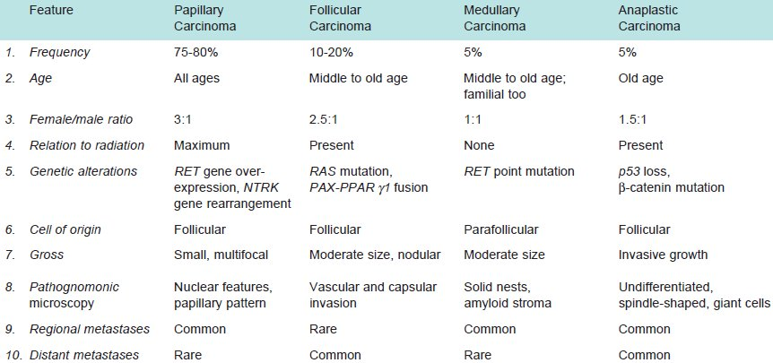

**Etiopathogenesis:**

Most important risk factor implicated in the etiology of thyroid cancer is external **radiation**, and to a some extent there is role of **TSH receptors** and **iodine excess**, while pathogenesis of thyroid cancer is explained on **genetic alterations**.

1. **External radiation**
2. **Iodine excess and TSH**

In regions where endemic goitre is widespread, addition of iodine to diet has resulted in increase in incidence of papillary cancer. Many well differentiated thyroid cancers express TSH receptors and thus respond to T4 suppression of TSH.

**3. Genetic basis**

Genetic alterations and mutations

* 1. Papillary Carcinoma: mutation in RET gene
  2. Follicular Carcinoma: mutation in RAS family of oncogenes
  3. Medullary Carcinoma: mutation in RET-protooncogenes
  4. Anaplastic Carcinoma: mutation in p53 tumor suppressor gene

**Papillary Thyroid Carcinoma**

* Most common type of thyroid carcinoma, comprising 75-85% of cases.
* Occur at all ages including children and young adults but the incidence is higher with advancing age.
* Females /males ratio 3:1.
* Slow-growing malignant tumour, solitary nodule.
* Involvement of the regional lymph nodes is common, spread to regional lymph nodes and cause cervical lymphadenopathy.

**Morphologic Features**

* Grossly, papillary carcinoma may range from microscopic foci to nodules up to 10 cm in diameter.
* Cut surface of the tumour is **greyish-white, hard** and **scar-like**. Sometimes the tumour is transformed into a **cyst**, into which numerous **papillae** project and termed *papillary cystadenocarcinoma.*

***Histologically,*** the following features are present

1. **Papillary pattern.** Papillae composed of **fibro-vascular stalk** and covered by **single layer of tumour cells.**
2. **Tumour cells.** The tumour cells have characteristic nuclear features due to **dispersed nuclear chromatin with ground-glass apperance** and**clear cytoplasm**. May form follicles and solid sheets.
3. **Invasion.** The tumour cells **invade the capsule** and **intra-thyroid lymphatics** but invasion of blood vessels is rare.
4. **Psammoma bodies.** Half of papillary carcinomas show typical **small, concentric**, **calcified spherules** called psammoma bodies in the stroma.

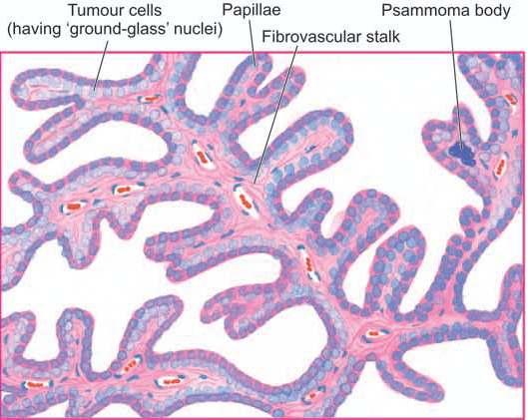

**Fig:** Papillary carcinoma thyroid. Microscopy shows branching papillae having flbrovascular stalk covered by a single layer of cuboidal cells having ground-glass nuclei. Colloid-filled follicles and solid sheets of tumour cells are also present.

**Follicular Thyroid Carcinoma**

* Common type of thyroid cancer, next to papillary carcinoma (10-20%)
* More common in middle and old age and has preponderance in females
* Correlation with endemic goitre
* Follicular carcinoma presents clinically either as a solitary nodule or as an irregular, firm and nodular thyroid enlargement.
* The tumour is slow-growing but more rapid than the papillary carcinoma.
* Regional lymph node metastases are rare but distant metastases by haematogenous route are common, esp. to the lungs and bones.

**Morphologic Features**

***Grossly,*** solitary adenoma like circumscribed nodule or cancerous irregular thyroid enlargement. The cut surface of the tumour is grey-white with areas of haemorrhages, necrosis and cyst formation and may extend to involve adjacent structures.

***Microscopically,*** the features are:

1. **Follicular pattern:** follicles of various sizes and may show trabecular or solid pattern. The tumour cells have hyperchromatic nuclei and the cytoplasm resembles that of normal follicular cells. Absence of papillae, ground-glass nuclei of tumour cells and psammoma bodies.
2. **Vascular invasion and direct extension:** to involve the adjacent structures (e.g. into the **capsule**) are significant features but lymphatic invasion is rare.

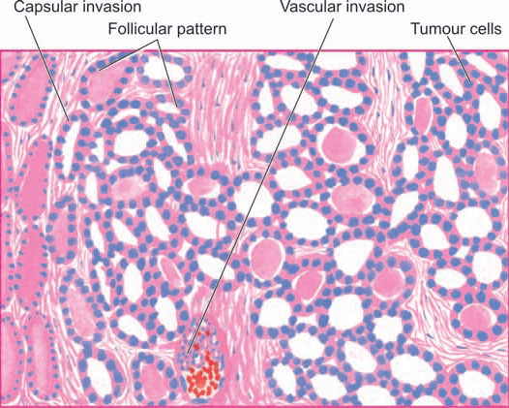

**Fig:** Follicular carcinoma, showing encapsulated tumour with invasion of a capsular vessel. The follicles lined by tumour cells are of various sizes and there is mild pleomorphism.